|  |  |
| --- | --- |
| NewLogoSm | **College of Engineering and Computer Science**  **Mechanical Engineering Department**  ***Mechanical Engineering 390***  ***Fluid Mechanics*** |
| Spring 2008 Number: 11971 Instructor: Larry Caretto |

**April 22 Homework Solutions**

**8.37 The following equation is sometimes used in place of the Colebrook equation.**



**for 10-6 < /D < 10‑2 and 5000 < Re < 108. An advantage of this equation is that given Re and /D, it does not require an iteration procedure to obtain f. Plot a graph of the percent difference in f as given by this equation and the original Colebrook equation for Reynolds numbers in the range of validity of the above equation with /D = 10-4.-**

The calculations were done on a spreadsheet that has been placed on the course web site. You can download it at <http://www.csun.edu/~lcaretto/me390/Colebrook.xls>. The results are shown in the figure below.



For the relative roughness of 10-4, it appears that the formula would be accurate beyond the upper limit of Re = 108, but is rapidly losing accuracy at the lower limit of Re = 5000.

**8.39 Two equal length, horizontal pipes, one with a diameter of 1 in., the other with a diameter of 2 in., are made of the same material and carry the same fluid at the same flow rate. Which pipe produces the larger head loss? Justify your answer.**

We know that for fully turbulent flow the head loss varies as 1/D5; and for laming flow the head loss varies as 1/D4; thus we expect the smaller pipe to have the larger head loss in these two regions. In intermediate regions, the head loss is given by the equation



The ratio of the heat loss in the two-inch pipe to that in the one-inch pipe, when Q and L are the same, depends only on differences in diameter and friction factor.



On the Moody diagram, the friction factor ranges from 0.008 to 0.1; the maximum possible value of f2/f1 is 0.1/0.08 = 12.5. Even this maximum possible range does not offset the factor of 1/32. Thus, we conclude that ***the larger pipe will have the smaller head loss***.

**8.47 Water flows at a rate of 0.040 m3/s in a 0.12-m-diameter pipe that contains a sudden contraction to a 0.06-m-diameter pipe. Determine the pressure drop across the contraction section. How much of this pressure difference is due to losses and how much is due to kinetic energy changes.**

A sketch of the contraction (from the solution manual for the Munson text) is shown at the left. We can write the energy equation for between the flow before the contraction (1) and the flow after the contraction (2). The head loss for a contraction is written in terms of the loss coefficient times the velocity after the contraction.

****We can find the velocities from the flow rate, which is constant, and the areas.



The loss coefficient is found from Figure 8.26 on page 440 with A2/A1 = (D2/D1)2 = [(0.06 m) / (0.12m)]2 = 0.25: KL = 0.4. Since the contraction is horizontal, z2 = z1 and our energy equation becomes.



The first term on the right represents the kinetic energy change and the second term is the loss term. Substituting in the velocity data, we can evaluate each term.



Multiplying the pressure head terms by the specific weight of water, 9.80 kN/m3from Table 1-6. gives the following results for pressure drop:



**8.54 Natural gas ( = 0.0044 slugs/ft3 and  = 5.2x10-5 ft2/s) is pumped through a horizontal 6-in-diameter cast-iron pipe at a rate of 800 lbf/hr. If the pressure at section (1) is 50 psi(abs), determine the pressure at section (2) 8 mi downstream if the flow is assumed incompressible. Is the incompressible assumption reasonable? Explain.**

The energy equation for the pipe flow is.



This is a horizontal pipe so z1 = z2 and for incompressible flow with a constant diameter, V1 = V2 so the only terms left in the energy equation are the pressure drop and the head loss.



The pipe diameter = 6 in = 0.5 ft and we have data for a weight flow so we find the velocity and the Reynolds number as follows.





So the flow is turbulent and we find the roughness for cast iron pipe as  = 0.00085 ft from Table 8.1 so /D = (0.00085 ft) / (0.5 ft) = 0.0017. From this relative roughness and Re = 7.587x104 we can find f = 0.0245 from the Moody diagram. Using this f on the right side of the Colebrook equation gives the following result.



Using this friction factor we can find the pressure drop.



If the initial pressure is 50 psi(abs) the downstream pressure is 50 psi – (294.6 psf) / (144 psi/psf), or ***p2= 48.0 psi***.

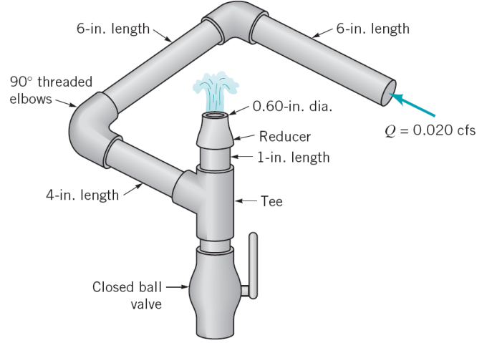**8.66 Water flows steadily through a 0.75-in-diameter, galvanized iron pipe system shown in the figure at the right at a rate of 0.20 cfs. Your boss suggests that friction losses in the straight pipe sections are negligible compared to losses in the threaded elbows and fittings of the system. Do you agree or disagree with your boss? Support your answer with appropriate calculations.**

From the diagram we see that the flow path goes through (6 in + 6 in + 4 in + 1 in) = 17 in of straight run pipe. In addition it flows through two elbows, the branch of a tee and a reducer before exiting to the atmosphere. The total head loss is the sum of the major and minor losses. If all the minor losses are based on the same velocity, V, the velocity in the straight run pipe sections, we can write the total head loss as follows.



We can find the water velocity from the flow rate of 0.20 ft3/s and the pipe diameter of 0.75 in = 0.0625 ft.



The velocity head that is used to compute the head loss is computed from this velocity.



Next, we find the Reynolds number, using the value of  = 1.21x10-5 ft2/s for water from Table 1.5.



So the flow is turbulent and we find the roughness for galvanized iron pipe as  = 0.0005 ft from Table 8.1 so /D = (0.0005 ft) / (0.0625 ft) = 0.0017. From this relative roughness and Re = 3.367x104 we can find f = 0.038 from the Moody diagram. Using this f on the right side of the Colebrook equation gives the following result.



With this friction factor we can compute the major head loss due to the straight run pipe that has a total of 17 in.



The minor loss coefficients are 2(1.5) = 3 for the two 90o threaded elbows, and KL = 2 for the threaded tee branch flow. There are no data in the text for the reducer, so we can approximate the loss coefficient as that of a sudden contraction; this should overstate the loss that we would expect from the more gradual reducer. Since the reducer reduces the diameter from 0.75 in to 0.60 in the area ratio is [(0.60 in)/(0.75 in)]2 = 0.64 and the loss coefficient is 0.15 for this area ratio according to figure 8.26. Since the loss coefficient for the sudden contraction uses the downstream velocity to compute the head loss and we want to have all the loss coefficients based on the same (upstream) velocity we can modify this loss coefficient as follows.



So the sum of the loss coefficients is 3 + 2 + 0.366 = 5.366, and the head loss due to the minor losses is



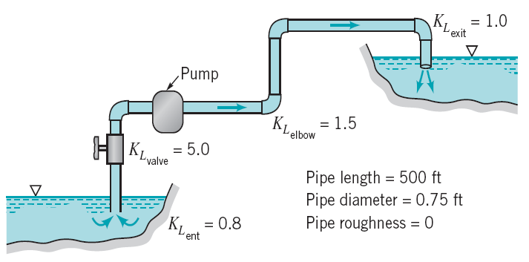So the total head loss is 3.544 ft + 0.556 ft = 4.100 ft, with 13.6% coming from the straight run pipe. You should probably tell your boss that she was basically correct that the minor losses are much more significant than the major losses, but the major losses do contribute 13.6% of the total loss and you think that you should include them in your calculations.

**8.75 The pump shown in the figure to the right delivers a head of 250 ft to the water. Determine the power that the pump adds to the water. The difference in elevation of the two ponds is 200 ft.**

We know the pump head is 250 ft and the relation between the pump head and the pump power is



In order to apply this equation we have to know the flow rate. We can see if we have enough information to compute the flow rate from the energy equation. We begin by writing the energy equation for a control volume between the surface of the lower pond, point 1, and the surface of the upper pond, point 2. The difference in elevations, z2 – z1 is given to be 200 ft, and since both ponds are open to the atmosphere at their surfaces, we have p1 = p2 = 0 and V1 = V2 = 0.



Setting V1 =V2 = p1 = p2 = 0 gives



Entering the given data for z2 – z1 and hs reduces the problem to one of finding V.



This needs to be an iterative solution since f depends on V. Substituting known values for the sum of the loss coefficients from the diagram (0.8 + 5 + 1.5 + 1.5 + 1.5 + 1.5 +1 = 12.8) and the other known terms in the head loss gives the following computational equation.



Use the kinematic viscosity of water from table 1.5,  = 1.21x10-5 ft2/s to develop a computational formula for the Reynolds number



So we have an iterative solution like the following:

1. Guess a value for Vpipe

2. Compute Re = 6.198x104Vpipe

3. Find the friction factor from the Moody diagram or equations

4. Use the value just found for f in the equation for V2pipe to find Vpipe

5. Continue the process in steps 1 to 4 until two values of Vpipe are sufficiently close.

If we start with a guess that Vpipe = 5 ft/s, we find Re = 3.099x105 and f = 0.0144. Solving the V2pipe equation gives Vpipe = 11.99 ft/s.

For the next iteration we can use the value just found, Vpipe = 11.99 ft/s, as our guess. That gives Re = 7.431x105 and f = 0.0123 and Vpipe = 12.39 ft/s.

For the third iteration we again use the value just found, Vpipe = 12.39 ft/s, as our guess. That gives Re = 7.677x105 and f = 0.0122 and Vpipe = 12.40 ft/s. This is very close to the value we used at the start of the calculations and we will use this as our final value.

We are finally able to find the power input to the pump.

